cqlsh is a command-line interface for interacting with Cassandra using CQL (the Cassandra Query Language). It is shipped with every Cassandra package, and can be found in the bin/ directory alongside the cassandra executable.

What is a Keyspace in Cassandra? A keyspace is **a data container in Cassandra, similar to a database in relational database management systems (RDMBS)**.

Practical 1

cqlsh>

cqlsh> CREATE KEYSPACE demo WITH replication = {'class': 'SimpleStrategy', 'replication_factor': 1};

cqlsh> CREATE KEYSPACE key WITH replication = {'class': 'SimpleStrategy', 'replication_factor': 3};

cqlsh> DESCRIBE key;

CREATE KEYSPACE key WITH replication = {'class': 'SimpleStrategy', 'replication_factor': '3'} AND durable_writes = true;

Writes in Cassandra are durable. All writes to a replica node are recorded both in memory and in a commit log on disk before they are acknowledged as a success. If a crash or server failure occurs before the memtables are flushed to disk, the commit log is replayed on restart to recover any lost writes.

cqlsh> use key ;

cqlsh:key> CREATE TABLE emp (emp_id int PRIMARY KEY ,emp_city text ,emp_name text,emp_sal varint);

cqlsh:key> select * from emp;

emp_id | emp_city | emp_name | emp_sal

--------+----------+----------+---------

(0 rows)

cqlsh:key> INSERT INTO emp (emp_id,emp_city ,emp_name ,emp_sal) VALUES (1,'Nagpur','Meghna',790000);

cqlsh:key>

cqlsh:key> INSERT INTO emp (emp_id,emp_city ,emp_name ,emp_sal) VALUES (2,'Nagpur','Dr.Sameer',1790000);

cqlsh:key> INSERT INTO emp (emp_id,emp_city ,emp_name ,emp_sal) VALUES (3,'Nagpur','Dinesh',10000);

cqlsh:key> select * from emp

... ;

emp_id | emp_city | emp_name | emp_sal

--------+----------+-----------+---------

1 | Nagpur | Meghna | 790000

2 | Nagpur | Dr.Sameer | 1790000

3 | Nagpur | Dinesh | 10000

(3 rows)

cqlsh:key>

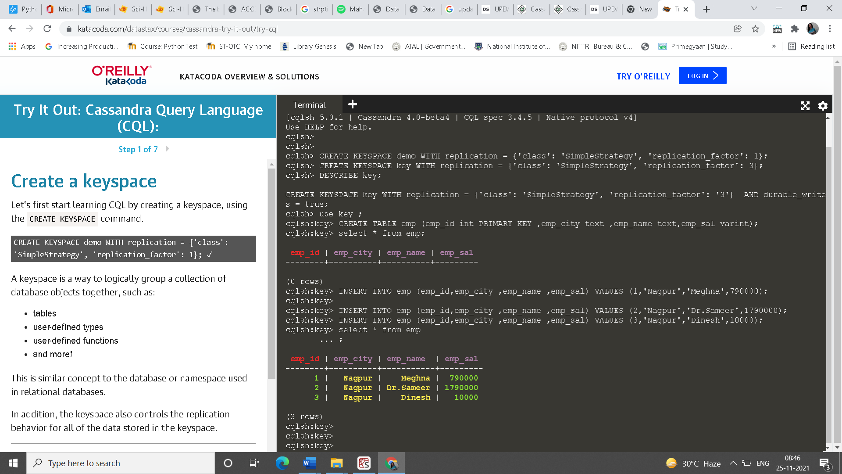

UPDATE emp set emp_city='Delhi' , emp_sal=20000 where emp_id=3;

cqlsh:key> select * from emp ;

emp_id | emp_city | emp_name | emp_sal

--------+----------+-----------+---------

1 | Nagpur | Meghna | 790000

2 | Nagpur | Dr.Sameer | 1790000

3 | Delhi | Dinesh | 20000

(3 rows)

cqlsh:key> DELETE from emp where emp_id=3;

cqlsh:key> select * from emp ;

emp_id | emp_city | emp_name | emp_sal

--------+----------+-----------+---------

1 | Nagpur | Meghna | 790000

2 | Nagpur | Dr.Sameer | 1790000

(2 rows)

cqlsh:key> DROP table emp;

The DROP command is used to remove table definition and its contents. Whereas the **TRUNCATE command is used to delete all the rows from the table**.